Length-Weight Analysis

Result #1 – Sample Sizes

len.bin 3 5 7 9 11 13 15 17
tx stage
8BF Fem 0 0 1 11 2 5 5 0
Grav 0 0 0 0 0 0 0 0
Juv 0 2 9 1 0 0 0 0
Male 0 0 0 2 5 11 0 0
8SBF Fem 0 0 4 10 11 20 14 1
Grav 0 0 0 0 0 12 12 3
Juv 2 20 23 3 0 0 0 0
Male 0 0 0 5 12 32 1 0
Fresh Fem 0 0 3 11 10 19 13 5
Grav 0 0 0 0 1 12 6 3
Juv 1 19 16 0 0 0 0 0
Male 0 0 2 9 15 23 5 0

Decision #1 – Permanently removed all juveniles from analysis.
The variability for the juveniles is unreasonably large and indicates that there were substantial issues with measuring the weight of juvenile specimens. The analysis will continue without the juveniles.
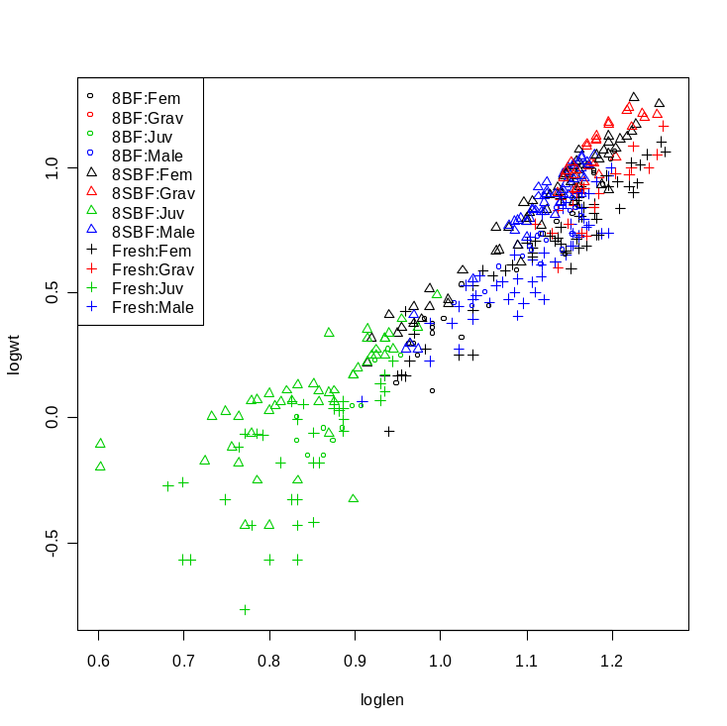
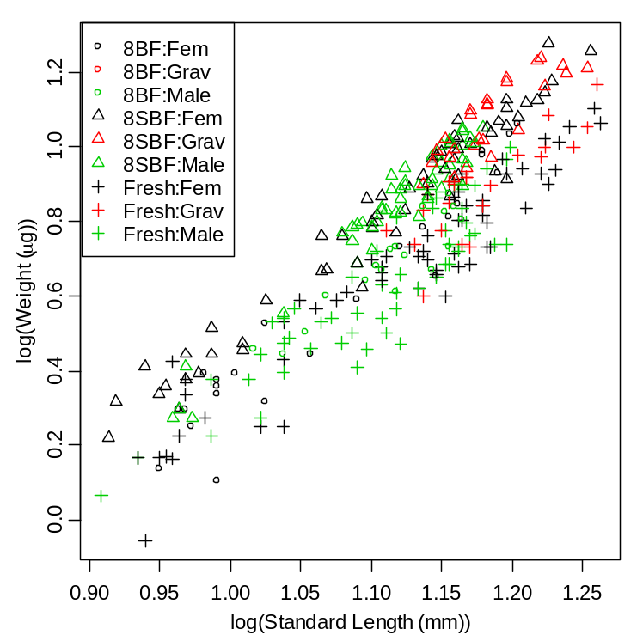

Decision #2 – Temporarily removed all gravids from analysis.
No gravid females were collected for the 8% buffered formalin treatment. I removed all gravid individuals to determine if there are any “difference” among male and female Mysids between 8% buffered formalin, 8% sugar buffered formalin and fresh preserved specimens. Later gravids will be added back in and female, male, and gravids will be compared between 8% sugar buffered formalin and fresh preserved specimens.

Result #2 – Comparison of relationship among stages (M&F) and tx (Fresh, 8BF,8SBF)
Two-way indicator variable regression indicates that the slopes of the log(wt) to log(len) relationship differs by treatment (p=0.022) but not by stage (p=0.454) or by the interaction between treatment and stage (p=0.129). Slope comparisons using the false discover rate method suggests that both the 8% buffered and 8% sugar buffered formalin have slopes significantly steeper than the fresh preserved group. The slopes of the 8% buffered and 8% sugar-buffered formalin groups did not differ significantly.

Anova Table (Type II tests) -- Response: logwt
Sum Sq Df F value Pr(>F)
loglen 13.5406 1 2586.8065 < 2e-16 ***
tx 1.9337 2 184.7045 < 2e-16 ***
stage 0.0032 1 0.6146 0.43380
loglen:tx 0.0405 2 3.8644 0.02222 *
loglen:stage 0.0029 1 0.5626 0.45389
tx:stage 0.0012 2 0.1099 0.89593
loglen:tx:stage 0.0216 2 2.0621 0.12930
Residuals 1.3348 255

Multiple comparison control procedures used: fdr

Multiple Slope Comparisons
comparison diff lwr upr raw.p adj.p
1 8SBF-8BF -0.04417 -0.38683 0.29850 0.79985 0.79985
2 Fresh-8BF -0.32885 -0.66386 0.00617 0.05434 0.08151
3 Fresh-8SBF -0.28468 -0.52989 -0.03947 0.02305 0.06915

Slope Information
level slopes lwr upr raw.p adj.p
3 Fresh 2.77581 2.61006 2.94155 0 0
2 8SBF 3.06049 2.87978 3.24120 0 0
1 8BF 3.10465 2.81351 3.39579 0 0

The intercepts differed between the 8% buffered and 8% sugar-buffered formalin groups. Thus, given the parallel lines between these two groups, the log(wt) of the 8% sugar-buffered formalin group is between 0.115 and 0.157 units higher than the log(wt) of the 8% buffered formalin group regardless of the log(len).

Tukey HSD on adjusted means assuming parallel lines.
comparison diff lwr upr p.adj
1 8SBF-8BF 0.1357996 0.1149345 0.1566647 2.464695e-14

Mean adjusted values at a covariate value of 1.10628447601932
8BF 8SBF
0.6740302 0.8098298

* Residuals were (visually) approximately normal, linear, and homoscedastic.

